FOR IMMEDIATE RELEASE
07/21/2021
WNCHA Presents: Shiloh, Past and Present
Join us (virtually) on Tuesday, August 12 from 6:30-8:00PM as the Western North Carolina Historical Association in partnership with the Osher Lifelong Learning Institute presents a multi-generational discussion of Asheville’s historic Shiloh community. We are joined by a special moderator—Jefferson Ellison of JAWBREAKING Creative.
Founded by newly freed people after the Civil War, Shiloh is one of Asheville’s oldest historically Black communities. Due to construction of the Biltmore Estate, and later changes wrought by highway and interstate development, the community boundaries have changed over the last century and a half. Many locals still refer to both old and new Shiloh. In this special panel, both a retired community historian (Anita White-Carter) and a young filmmaker and activist (Ria Young) join us to discuss their research, memories, and past and present connections to this community and its residents. Our presenters will also answer audience questions in a Q&A session at the end.
About the Speakers:
Anita White-Carter grew up in Shiloh and has spent most of her adult years in the community. She retired from the UNC-Asheville library after 30 years as a Public Services Librarian. She established the Shiloh Little Free Library located in the Shiloh Community Garden. She is active in the community and is currently researching the history of the neighborhood. She is a graduate of Allen High School (Asheville), Bennett College (Greensboro), and the University of Pittsburgh (Pennsylvania).
Maria “Ria” Young is a former collegiate All-American Basketball Player, director, writer, author, screen and playwright from Asheville, NC. She hails from the Shiloh community who have heavily influenced the stories she tells. In 2017, Maria released her memoir Lost In A Game: The Road To Self-Discovery detailing her collegiate journey as a black athlete with little to no self-identity navigating the trials and tribulations of collegiate basketball at a PWI. Maria has taken her story all over the southeast during speaking engagements at multiple colleges/universities and high schools. She made her stage and directorial debut in ‘Transition’, which is her last extension of her 2017 memoir in December of 2020, followed by her directorial debut of “The Power of Our Village” short in February of 2021.
Tickets: $3 for WNCHA members/ $7 for General Admission. We also have no-cost, community-funded tickets available. We want our events to be accessible to as many people as possible. If you are able please consider making a donation along with your ticket purchase. These donations are placed in our Community Fund, which allows us to offer tickets at no cost to those who would not be able to attend otherwise.
Registration: Advance registration is required for this virtual event. A Zoom link will be sent to all registrants in a confirmation email. This event will be recorded and available on our website afterward. Register at www.wnchistory.org/events
For any questions email Trevor Freeman at education@wnchistory.org or call 828-253-9231.
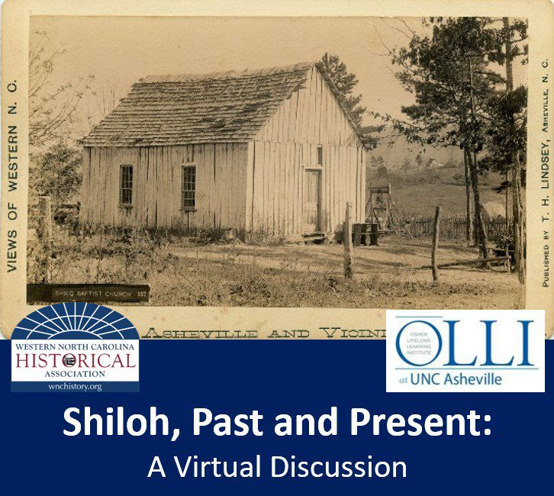
(Image: Shilo[h] Baptist Church, courtesy Buncombe County Special Collections)

